**Applied Data Science – 1**

**Assignment – 2**

**Name :** Barath Nochipalayam Subramaniam

**Student ID :** 22085249

**Github Link:**  <https://github.com/Barathnsj/Applied-Data-Science--Assigment-2>

**Dataset Link :** <https://data.worldbank.org/topic/climate-change>

**World Climate Change Data**

The Climate Change dataset comprises data on a variety of topics, including forestry, fisheries, agricultural land, agri-food and services, CO2 emissions, population increase, and more. The Global Environmental Facility (GEF), the World Bank, and the United Nations Development Program (UNDP) are among the sources where the dataset is accessible. Human activity is the cause of the global phenomenon known as climate change. You can use descriptive statistics, correlation analysis, and other methods of dataset analysis to investigate the connections between these variables and climate change.

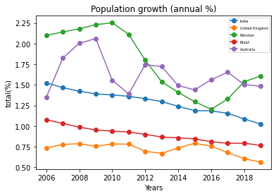

Population emissions are shown for the years 2006 through 2019. Our goal is to offer important insights into the intricate linkages that exist between the acts of humans and climate change by examining the patterns and correlations among different indicators. We take into account the developments in the following important indicators: the rate of population increase, CO2 emissions. The amount of land used for agriculture, energy and water consumption. We note that these metrics' trajectories closely correspond with the increase in greenhouse gas emissions and the effects of climate change. The world's population is growing quickly, which exacerbates climate change by contributing to deforestation. For India, the population growth rate has been consistently higher than 1.5% from 2006 to 2019. This indicates that during this time, the population of the nation has likely been growing quickly. Comparably, the rates of population growth in nations such as Australia have exhibited variability. They have stayed comparatively high, nevertheless, on average. Brazil's population growth rate, on the other hand, has significantly slowed down in recent years. The decline in the growth rate between 2006 and 2019 demonstrates the nation's attempts to slow down population expansion. It's crucial to remember that these patterns in population growth rates do not prove beyond a reasonable doubt that they are caused by climate change. A definitive causal relationship between population increase and climate change can only be established by more thorough investigation and analysis using a wider range of variables and analytical methods.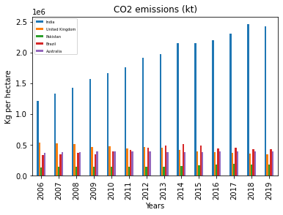

The High Co2 emission due to human activity, such as burning fossil fuels, deforestation, and cement manufacturing, is carbon dioxide, an odorless and colorless gas. Since the industrial revolution, the amount of CO2 in the Earth's atmosphere has increased by 43%, mostly as a result of burning fossil fuels. It gets harder for Earth to keep a steady temperature as more CO2 is absorbed by the planet. Based on the available statistics, India's carbon dioxide emissions rose from 1.3 (Gt) in 2006 to 2.4 Gt in 2019. In terms of global rankings, India's CO2 emissions rose from the 20th to the 22nd position. Changes in the population, legislation, economic growth, and other factors will all cause emissions to fluctuate in the future. For the purpose of combating climate change, it is therefore imperative to monitor these changes and comprehend the underlying causes of them.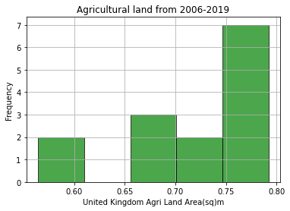 Skewness: -1.012 , Kurtosis: -0.073

The asymmetry or "lopsidedness" of a probability distribution is quantified statistically as skewness. Put more simply, it shows the extent and direction of skew, or the divergence from horizontal symmetry, in a dataset.

When the skewness for agricultural land in the UK is negative, it means that the data distribution is left-skewed. Since the data relates to agricultural land in the United Kingdom, negative skewness may indicate that over time, there have been more occurrences of above-average than below-average values for agricultural land area. This could suggest that agricultural land area is rather stable, with fluctuations leaning more toward the higher end of spectrum.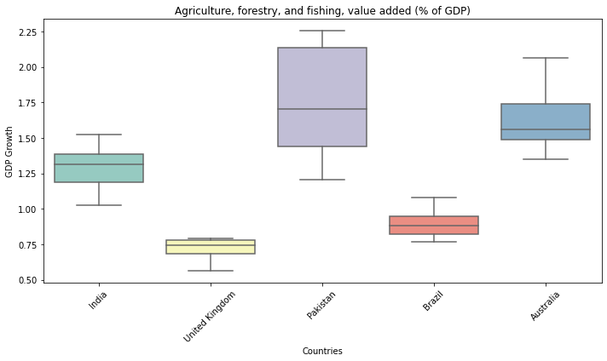 This measure shows what proportion of a nation's GDP comes from the value added that comes from the fisheries, forestry, and agriculture industries put together comprises tasks associated with tilling land, growing crops, and rearing animals. High percentage nations could be highly dependent on traditional agriculture and the natural resource sectors. Pakistan is the nation with the greatest total values when the "Agriculture, forestry, and fishing, value added (%) of GDP)" for the chosen countries is analyzed.

Pakistan's values are notably low in the first quartile (Q1), suggesting that a sizable amount of the data is concentrated in the lower range. Pakistan, however, shows a large range in the third quartile (Q3), indicating a broad distribution of values with a significant fraction residing in the higher range. On the other hand, out of all the countries chosen, Brazil and the United Kingdom exhibit the lowest values. Their boxplots are more compact, which indicates more stable results when it comes to the GDP contribution of forestry, fisheries, and agriculture as a proportion. The numbers in the first and third quartiles in both situations. A larger first quartile (Q1) is found in the analysis of India's profile, indicating that a sizable portion of the data falls within a higher range. In contrast to the lower range, the third quartile (Q3) is comparatively low, suggesting a tighter upper range.

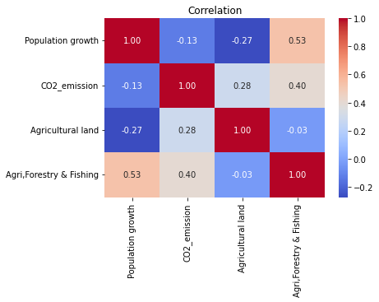 Population Growth, CO2 Emissions, Agricultural Land, and Agriculture, Forestry, and Fishing Value Added are correlated, and this correlation sheds light on possible links between these important variables. From -1 to 1, the correlation coefficient is the range.

If population growth raises the demand for agricultural goods and, in turn, increases the amount of land used for agriculture then there may be a positive link in this case. A positive link could imply that nations with larger CO2 emissions are typically those with more agricultural operations, which need more land.